Accessing digital maps- E-Map Website

All LEAs have access to GIS data and maps of their area and these should be obtainable by schools if requested. However, BECTa are currently running a MapPilot scheme where schools can register their interest and gain free access to certain maps online with copies sent to their email address. Here is how you can access and obtain a map for use in your school for educational purposes only (see e-map site for further conditions of use)

1. Access e-map website (http://www.emapsite.com/login/ )

2. If registered, login. If not registered click on ‘Register’ and complete the form (however, you will not be able to will not be able to access the free maps until you are authorized).

3. When logged in, type in the postcode of the map area you want under ‘Geosearch’ and click on the magnifying glass icon:

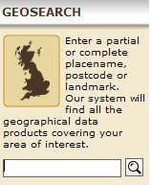

4. Click on the correct place link.

5. Choose the map type you want (OS MasterMap) and click on ‘Draw area’:

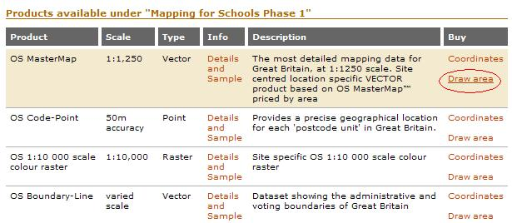

6. Use the map tools (zoom & move) to get the place you want. It is possible to change the backdrop map if you prefer (OS StreetView is easy to see):

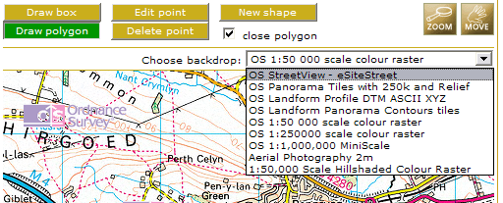

7. Click on ‘draw box’, position the cursor in the bottom right hand corner of the area you want and left click, then the top left hand corner and the box will be completed:
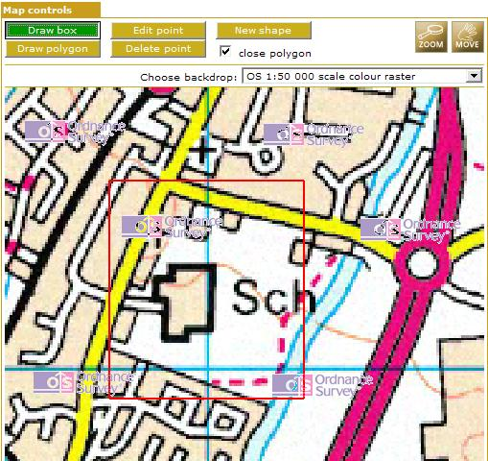

8. Scroll down the page and click on ‘add to basket’.

9. In the drop down menu, choose ‘shp’ (shapefile), then ‘next’:
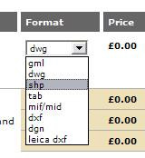

10. Check the ‘Accept Licenses’ box, give the purchase order a name, then ‘buy basket’.

- The map file will then be sent to your registered email address.

- Unzip the email attachment and the map file is ready to be put into AEGIS. If you are using a different GIS software package, check the manual to see which file types your program accepts before requesting the map file.

